A
PROJECT REPORT ON
Volatility Detection in Intraday market
OF
BACHELOR OF TECHNOLOGY
CSE (AI&DS)
SUBMITTED BY
Himanshu Mukesh Laddha
ISTU No.240100300

Jaydeep Vijay Agale
ISTU24010030080

Sai Rajendra Garudkar
ISTU24010030084

DEPARTMENT OF COMPUTER ENGINEERING
G H RAISONI RAISONI INTERNATIONAL SKILL TECH
UNIVERSITY, PUNE
2025-26

CERTIFICATE
This is to certify that the project report entitled
Volatility Detection in Intraday market
Submitted by
Himanshu Mukesh Laddha – Roll No: SA 208
Jaydeep Vijay Agale - Roll No: SA210
Sai Rajendra Garudkar – Roll No: SA 228
is a bonafide students of this institute and the work has been carried out by them under the supervision of Prof. Jayvrat Dwivedi and it is approved for the partial fulfillment of the requirement of the G H Raisoni International Skill Tech University, Pune, for the award of the degree of Bachelor of Technology in CSE ( AI & DS) in the academic year 2025-26.
Prof. Jayvrat Dwivedi (Dr. S S Balwante) Subject Faculty H.O.D.

Date:
Place: Pune

ACKNOWLEDGMENT
It gives us great pleasure in presenting Volatility Detection in Intraday Market as my B.Tech. project. Words have never seemed as inadequate as now when I am endeavoring to express our gratitude at the culmination of our B. Tech. Project to all those who have made it possible. Even the best efforts are waste, without the proper guidance and advice of our project guide Prof. Jayvrat Dwivedi for the consistent guidance, co-operation, inspiration, practical approach and constructive criticism, which provided us the much-needed impetus to work hard & also thanks Dr. S S Balwante Head of Computer Engineering Department for their continuous support & valuable suggestions.
We take this opportunity to thank Dr. Rahat Khan, I/C Dean SOET for her whole hearted support, motivation & valuable suggestions.
We would also like to thank Prof. Jayvrat Dwivedi our Project Coordinators for their valuable support in providing us with the required information.
At the end, we would like to give special thanks to all staff members from Computer Engineering Department of G H Raisoni International Skill Tech University, Pune & our colleagues for their kind support & timely suggestions.
Himanshu Mukesh Laddha
(Roll No. SA 208)
Jaydeep Vijay Agale
( Roll No. SA 210)
Sai Rajendra Garudkar
(Roll No. SA 228)

ABSTRACT
The Volatility Detection in Intraday Market project focuses on understanding how prices move within a single trading day and identifying moments when the market becomes unusually active or unstable. Intraday markets can change very quickly, and recognizing these shifts in volatility is important for traders, analysts, and anyone interested in financial data. Also we use linear regression machine learning model for this project.
This project uses data-driven techniques to analyze high-frequency market data and highlight patterns in price fluctuations. By calculating volatility indicators, it helps distinguish between calm periods—where prices move slowly—and high-volatility phases, where sharp price changes occur. These insights can be useful for adjusting trading strategies, managing risk, or simply gaining a clearer picture of market behavior.
This project focuses on analyzing intraday volatility in the Nifty 50 index, identifying volatility spikes, classifying market regimes, and predicting the next candle’s opening price using statistical and machine learning techniques.
The approach also reflects real-world market characteristics, such as volatility clustering, where high volatility tends to come in bursts, and predictable patterns during market opening and closing hours. By capturing these trends, the project makes it easier to understand how and when the market becomes more dynamic.
Overall, this repository serves as a practical and educational tool. It demonstrates how simple analytical methods can turn raw intraday data into meaningful insights, helping users better interpret market movements and make more informed decisions.
Keywords:
Intraday Trading, Market Volatility, Volatility Detection, Financial Time Series, High-Frequency Data, Algorithmic Trading, Risk Management, Volatility Clustering, Price Fluctuations, Trading Signals, Quantitative Analysis, Market Behavior

TABLE OF CONTENTS
CERTIFICATE ii
ACKNOWLEDGMENT iii
ABSTRACT iv
TABLE OF CONTENTS v
LIST OF ABBREVIATIONS vi
Chapter 1 Introduction 01
1.1 Overview 01
1.2 Motivation 02
1.3 Problem Definition & Objectives 02
1.4 Project Scope & Limitations 03
Chapter 2 Literature Survey 04
Chapter 3 Software Requirements Specification 05
3.1 Functional Requirements 05
3.2 Non-Functional Requirements 06
3.3 System Requirements 06
Chapter 4 System Design 07
4.1 System Architecture 07
4.2 Data Flow Diagram 08
09
Chapter 5 Project Implementation 10
5.1 Modules Overview 10
5.2 Algorithm Details 11
5.3 Tools & Technologies Used 12
Chapter 6 Results 13
6.1 Outcomes 13
Chapter 7 Conclusion 14
7.1 Conclusion 14
7.2 Future Work 14
7.3 Applications 15
References 16

Abbreviation | Full Form
SRS | Software Requirements Specification
DFD | Data Flow Diagram
UML | Unified Modeling Language
OHLC | Open, High, Low, Close
CSV | Comma-Separated Values
API | Application Programming Interface
SD | Standard Deviation
ML | Machine Learning
GUI | Graphical User Interface
NPL | Numerical Python Library

LIST OF ABBREVIATIONS

Chapter 01
Introduction

1.1 Overview
This project, Volatility Financial markets exhibit rapid price fluctuations, especially in intraday trading. Detecting volatility patterns helps traders understand risk, identify trading opportunities, and improve decision-making.
This project focuses on analyzing intraday volatility in the Nifty 50 index, identifying volatility spikes, classifying market regimes, and predicting the next candle’s opening price using statistical and machine learning techniques .Volatility Detection in Intraday Market, focuses on analyzing intraday data to identify patterns of volatility. By applying data analysis techniques, linear regression and volatility indicators, the system aims to detect periods of high and low market activity. Understanding these patterns can help traders and analysts make better decisions and improve trading strategies.

1.2 Motivation
The primary motivation behind this project is the increasing importance of data-driven decision-making in financial markets. Traders often struggle to interpret rapid market movements and identify the right time to enter or exit trades. Detecting volatility effectively can provide a significant advantage by highlighting potential risks and opportunities.
Additionally, with the growth of algorithmic trading and quantitative finance, there is a need for tools that can process large volumes of market data and generate meaningful insights. This project aims to bridge that gap by offering a simple yet effective approach to volatility detection.

1.3 Problem Definition & Objectives
Intraday markets generate large amounts of data, making it difficult to manually identify volatility patterns. The key problem addressed in this project is how to accurately detect and analyze volatility in real-time or near real-time using computational methods.
Objectives of the project include:
- To analyze intraday market data and extract meaningful patterns
- To develop methods for detecting volatility using statistical indicators
- To identify periods of high and low volatility
- To provide insights that can support trading and risk management decisions

1.4 Project Scope & Limitations
Scope:
- Focuses on intraday market data analysis
- Applies basic statistical and analytical techniques for volatility detection
- Can be used for educational purposes and as a foundation for trading strategies
- Helps in understanding short-term market behavior
Limitations:
- Accuracy depends on the quality and availability of data
- Does not guarantee profitable trading outcomes
- Limited to specific indicators and may not capture all market factors
- Real-time implementation may require additional optimization and resources

Chapter 2

Literature Survey

Volatility is a key concept in financial markets, widely studied for its role in risk management and trading decisions. One important observation in financial data is volatility clustering, where periods of high volatility are followed by high volatility, and low follows low, indicating that market movements are not entirely random.
Traditional models such as ARCH and GARCH have been commonly used to analyze and predict volatility. These models effectively capture time-varying fluctuations in financial data. Research also shows that intraday data provides more detailed insights compared to daily data, as it reflects real-time market behavior and rapid price changes.
Studies on intraday markets highlight specific patterns, such as increased volatility during market opening and closing hours due to higher trading activity and information flow. Factors like trading volume, liquidity, and number of transactions also significantly influence volatility levels.
In recent years, modern approaches have combined statistical models with machine learning techniques to improve accuracy. Methods such as clustering and regime detection help identify different market conditions, making it easier to adapt trading strategies.
Overall, existing research shows that volatility can be analyzed and partially predicted using data-driven methods, providing a strong foundation for intraday volatility detection systems.

Chapter 03
Software Requirements Specification

3.1 Functional Requirements
Functional requirements describe the core features and operations of the system.
- The system should be able to collect and process intraday market data.
- It should calculate volatility using appropriate statistical indicators.
- The system must identify and classify periods of high and low volatility.
- It should allow users to input or select datasets for analysis.
- The system should display results in a clear and understandable format (charts/graphs or summaries).
- It must support basic data preprocessing such as cleaning and formatting.
- The system should generate outputs that can assist in trading or analysis decisions.

3.2 Non-Functional Requirements
Non-functional requirements define the quality and performance aspects of the system.
- Performance: The system should process data efficiently with minimal delay.
- Accuracy: Results should be reliable and based on correct calculations.
- Usability: The interface should be simple and easy to use.
- Scalability: The system should handle increasing amounts of data if required.
- Reliability: The system should perform consistently without errors or crashes.
- Maintainability: The code should be modular and easy to update or modify.
- Security: Data handling should ensure basic protection and integrity.

3.3 System Requirements
Hardware Requirements:
- Computer/Laptop with minimum 4GB RAM (8GB recommended)
- Processor: Intel i3 or higher
- Stable internet connection (for data access, if required)
Software Requirements:
- Operating System: Windows / Linux / macOS
- Programming Language: Python
- Libraries/Tools: Pandas, NumPy, Matplotlib/Seaborn, Scikit-learn (if used)
- IDE: Jupyter Notebook / VS Code / PyCharm

Chapter 04
System Design

4.1 System Architecture
The system follows a modular architecture to ensure flexibility and ease of development. It consists of the following main components:
- Data Collection Module: Responsible for acquiring intraday market data from datasets or external sources.
- Data Preprocessing Module: Cleans and formats the data by handling missing values and organizing it for analysis.
- Volatility Calculation Module: Applies statistical methods to compute volatility indicators from the processed data.
- Analysis & Detection Module: Identifies patterns and classifies periods into high or low volatility.
- Visualization Module: Presents results through graphs, charts, or summaries for better understanding.
The architecture ensures smooth data flow between modules and allows future enhancements such as real-time data integration or advanced analytics.

4.2 Data Flow Diagram (DFD)
Level 0 (Context Diagram):
- User provides intraday market data
- System processes data and outputs volatility insights
Level 1 DFD:
- Input Data: User uploads or selects dataset
- Preprocessing: Data cleaning and formatting
- Volatility Calculation: Apply indicators and compute values
- Analysis: Detect volatility patterns
- Output: Display results in graphical or textual format
This flow ensures that raw data is systematically transformed into meaningful insights.

3. Sequence Diagram:
- User uploads data → System preprocesses → Calculates volatility → Analyzes patterns → Displays results
These diagrams help in understanding the structure, behavior, and interaction of different components within the system.

Chapter 05
Project Implementation

5.1 Modules Overview
The project is divided into several modules to ensure organized development and easy maintenance.
- Data Collection Module:
This module is responsible for obtaining intraday market data from available datasets or external sources.
- Data Preprocessing Module:
It handles cleaning of data, removal of missing values, and formatting the dataset for further analysis.
- Volatility Calculation Module:
This module computes volatility using statistical measures such as standard deviation or price returns.
- Analysis Module:
It identifies patterns in volatility and classifies periods into high and low volatility zones.
- Visualization Module:
This module presents the results using charts or graphs, making it easier for users to interpret the data.

5.2 Algorithm Details
The system follows a step-by-step algorithm to detect volatility:
- Input Data: Load intraday market data (price, time, volume).
- Data Cleaning: Handle missing or inconsistent values.
- Return Calculation: Compute price returns using percentage change.
- Volatility Calculation:
  - Apply statistical methods such as rolling standard deviation.
  - Identify volatility values over a fixed time window.
- Threshold Setting: Define thresholds to classify volatility as high or low.
- Pattern Detection: Analyze and label volatility regions.
- Output Generation: Display results through graphs or summaries.
This algorithm ensures systematic processing and accurate identification of volatility patterns.

5.3 Tools & Technologies Used
- Programming Language: Python
- Libraries:
  - Pandas (data manipulation)
  - NumPy (numerical computations)
  - Matplotlib / Seaborn (data visualization)
- Development Environment: Jupyter Notebook / VS Code / PyCharm
- Version Control: Git and GitHub
- Data Source: Intraday market datasets (CSV or API-based)

Chapter 06
Results

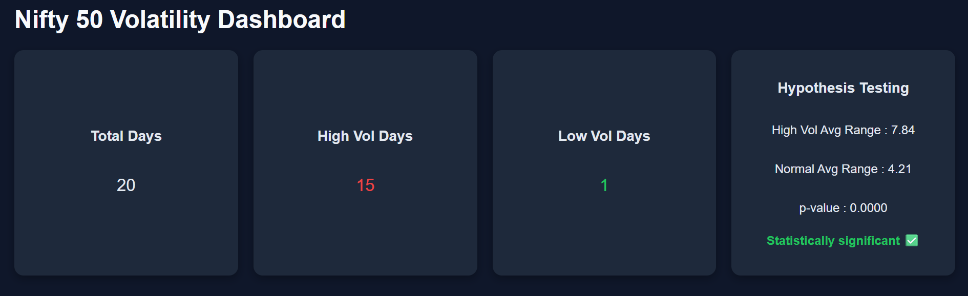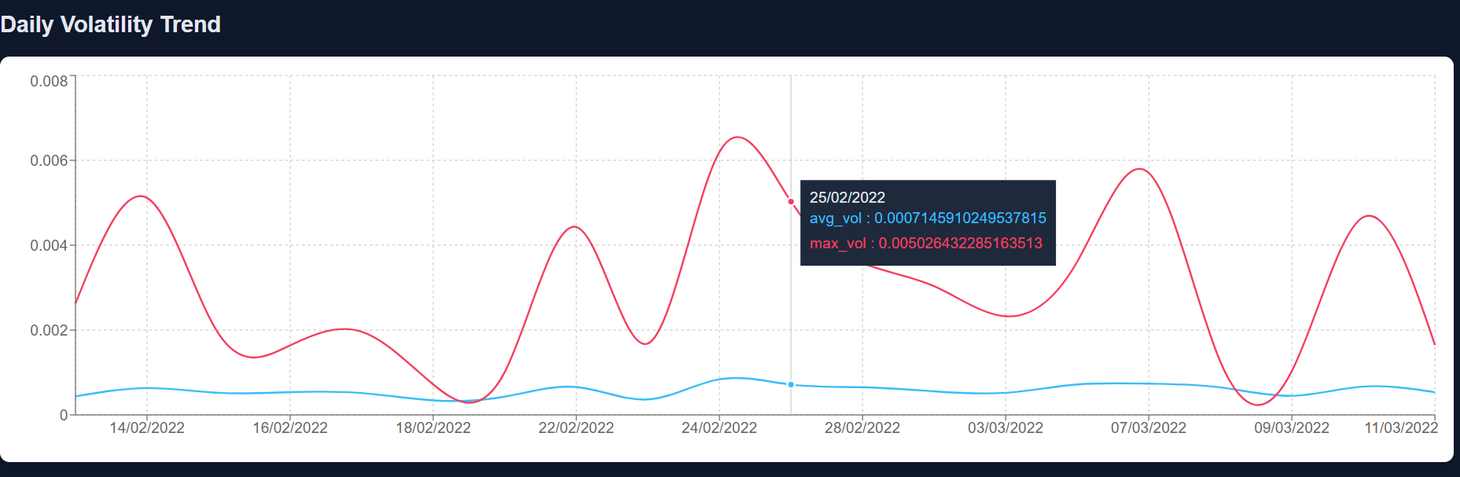

1. Daily Volatility Trend Chart
What it shows:

Line chart of:
avg_vol (average volatility per day)
max_vol (maximum volatility per day)

What we are analyzing:
How volatility changes over time
Identify high volatility days
Detect sudden spikes in market risk

Logic used:
Data fetched from /daily-summary
Two lines plotted:
Avg volatility → smooth trend
Max volatility → extreme movements
Used animation (setInterval) to create gradual movement (like live graph)

Insight:
When max_vol is much higher than avg_vol → market had sudden spikes

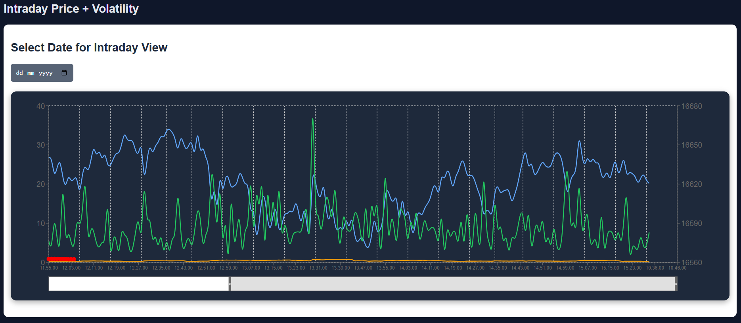
2. Intraday Price + Volatility Chart
What it shows:
Price (close)
Volatility (rolling_vol_15)
Activity (range)
Spike points (scatter)

What we are analyzing:
Relationship between:
Price movement
Volatility
Market activity
Detect exact moments of volatility spikes

Logic used:
Rolling volatility calculated (15-period window)
Range = High - Low
Dual Y-axis:
Right → Price
Left → Volatility & Range
Scatter plot marks vol_spike = true

Insight:
When volatility spikes → price moves sharply
Helps identify risky trading periods

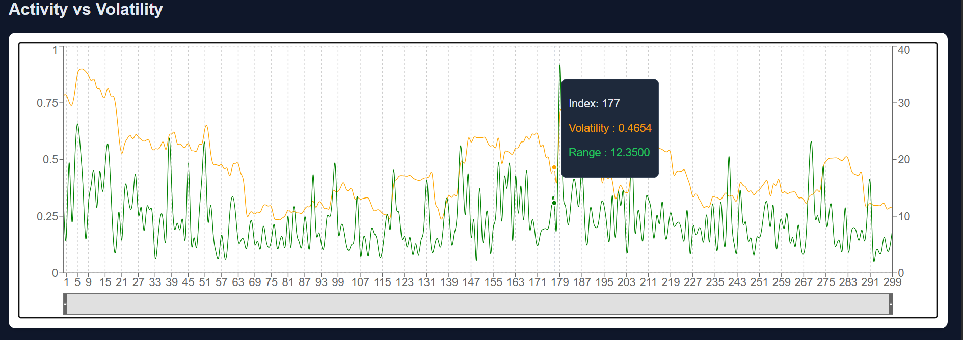

3. Activity vs Volatility Chart
What it shows:
Volatility vs Range (activity)
What we are analyzing:
Whether higher volatility = higher market movement

Logic used:
Volatility (rolling_vol_15)
Range (price movement)
Custom tooltip shows both values together

Insight:
Strong correlation → confirms volatile markets have larger price swings

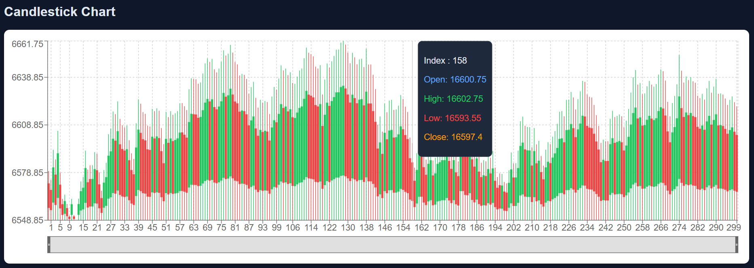

4. Candlestick Chart
What it shows:
OHLC (Open, High, Low, Close)
What we are analyzing:
Price behavior visually

Market sentiment:
Green → bullish
Red → bearish

Logic used:
Custom candlestick component:
Line → High to Low (wick)
Rectangle → Open to Close (body)
Tooltip shows full OHLC data

Insight:
Helps understand price structure during volatility

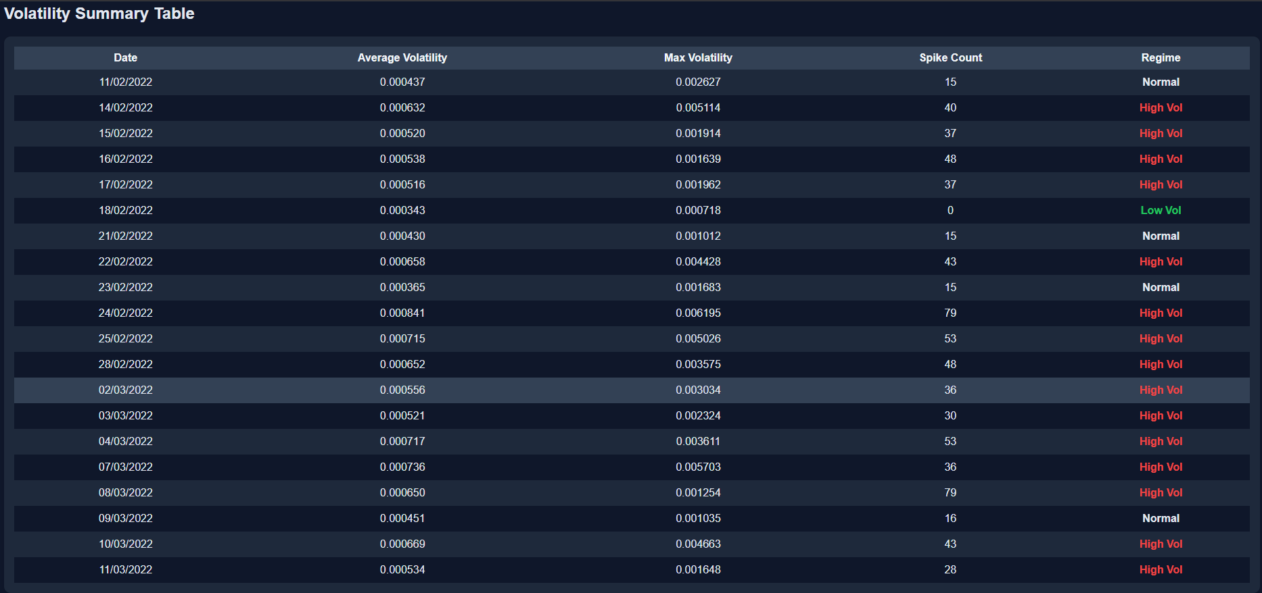

5. Volatility Summary Table
What it shows:
Daily stats:
Avg volatility
Max volatility
Spike count
Regime (High / Low / Normal)

What we are analyzing:
Categorizing days into regimes
Identifying high-risk days

Logic used:
Conditional coloring:
Red → High Vol
Green → Low Vol
Hover effects for better UI
Insight:
Quick overview of market conditions

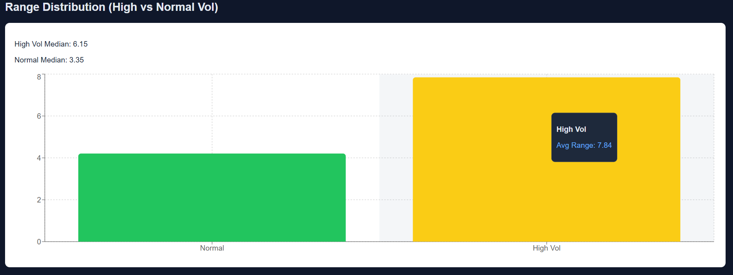

6. Range Distribution (Bar Chart)

What it shows:
Average range for:
Normal volatility days
High volatility days

What we are analyzing:
Difference in market movement between regimes
Logic used:
Aggregated mean values from backend
Bar chart used instead of line (comparison problem)
Insight:
High volatility days clearly have larger price movement

outcome
The project successfully detects and analyzes intraday market volatility using statistical methods. It identifies periods of high and low volatility from market data and presents them in a clear and visual format. The results highlight common patterns such as increased volatility during market opening and closing hours.
Additionally, the system demonstrates effective data preprocessing and handling of intraday datasets. It captures important characteristics like volatility clustering, where high-volatility periods occur consecutively. The project also provides meaningful insights through graphical representations, making it easier to understand market behavior.
Overall, the system proves that simple analytical techniques can be used to extract valuable information from financial data, supporting better decision-making in trading and risk management.

Chapter 07
Conclusion

7.1 Conclusion
The Volatility Detection in Intraday Market project successfully demonstrates how intraday financial data can be analyzed to identify volatility patterns. By applying statistical techniques such as return calculation and rolling standard deviation, the system effectively distinguishes between high and low volatility periods.
The project highlights important market behaviors, including volatility clustering and increased activity during opening and closing trading hours. The use of visualization further enhances the understanding of price movements and market trends.
Overall, the system achieves its objective of transforming raw intraday data into meaningful insights. It shows that even simple analytical approaches can provide valuable support for trading decisions and risk management. The project also serves as a strong foundation for further research and development in financial data analysis.

7.2 Future Scope
Although the project provides useful insights, there are several opportunities for improvement and expansion:
- Integration of real-time data for live volatility tracking
- Use of advanced machine learning models for more accurate predictions
- Incorporation of additional indicators and technical analysis tools
- Development of a user-friendly web or mobile application interface
- Extension to multiple financial markets such as stocks, forex, or cryptocurrencies
- Implementation of automated trading strategies based on detected volatility
With these enhancements, the system can evolve into a more powerful and practical tool for real-world financial analysis and decision-making.

References
• Engle, R. F. (1982). Autoregressive Conditional Heteroskedasticity with Estimates of the Variance of United Kingdom Inflation. Econometrica.
• Bollerslev, T. (1986). Generalized Autoregressive Conditional Heteroskedasticity. Journal of Econometrics.
• Tsay, R. S. (2010). Analysis of Financial Time Series. Wiley Publications.
• Hull, J. C. (2018). Options, Futures, and Other Derivatives. Pearson Education.
• Pandas Documentation. (2024). Python Data Analysis Library. Available at: https://pandas.pydata.org
• NumPy Documentation. (2024). Numerical Python Library. Available at: https://numpy.org
• Matplotlib Documentation. (2024). Visualization with Python. Available at: https://matplotlib.org
• Research Paper: Intraday Volatility Patterns in Financial Markets. Available on ResearchGate.
• GitHub Repository: Volatility Detection in Intraday Market. Available at:
https://github.com/Himanshu-git1414/Volatility-Detection-in-Intraday-Market.git

